Year 1 Love to Learn – Term 6
Weekly Expectations:
- Frequent reading logged in your Reading Record
- Weekly phonics learning – read the real and nonsense words and write a sentence using a word containing that sound!
Throughout the term, you are welcome to choose any of the below activities and showcase what you have done in your homework folder on paper or send in a photo. The activities in the shaded boxes link to our learning in school.
Make a sock puppet | Make the longest daisy chain that you can | Make some fruit ice lollies
Go rock pooling | Roll down a hill | Record different sounds and ask others to guess what they are
Follow some instructions to make a tasty treat!  Challenge – Can you write your own instructions? | Go for a walk around your local area with your adult. Can you write a list of features you can spot?  (church, shops, ponds, play parks etc) | Can you keep a weather diary for a week? What did you wear each day?

Your Love to Learn Celebration Day will be on Monday 20th July so remember to bring in your folder!
YEAR 1 TERM 6 PHONICS HOME LEARNING
Home Learning Set 5.6  aw | Home Learning Set 12.6  ur | Home Learning Set 19.6  ow | Home Learning Set 26.6  ai | Home Learning Set 3.7  oa | Home Learning Set 10.7  ew
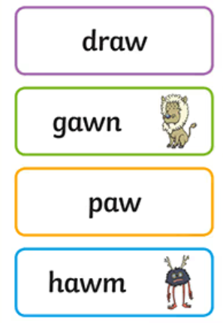 | 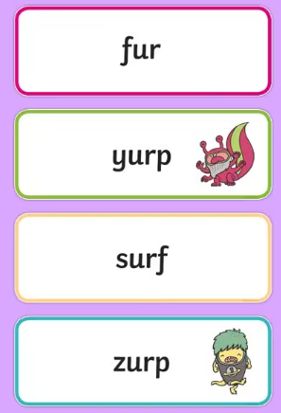 | 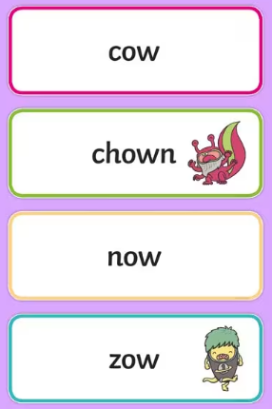 | 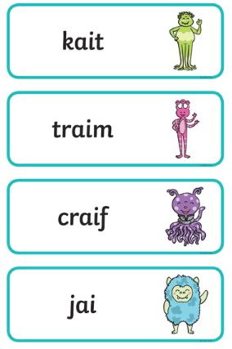 | 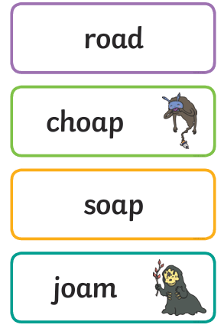 | 

