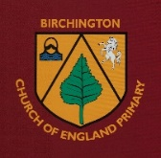

Helping at Home with
Physical Development
The Early Learning Goal for Physical Development in Year R is:
Gross Motor Skills:
Negotiate space and obstacles safely, with consideration for themselves and others. Demonstrate strength, balance and coordination when playing. Move energetically, such as running, jumping, dancing, hopping, skipping and climbing.

Fine Motor Skills:
Hold a pencil effectively in preparation for fluent writing – using the tripod grip in almost all cases. Use a range of small tools, including scissors, paintbrushes and cutlery. Begin to show accuracy and care when drawing.
In Year R we spend time creating opportunities and experiences for the children which strengthen their muscles, these skills are called gross and fine motor skills. Gross motor skills involve large movements using larger muscles such as the legs, arms and core. Fine motor skills involve developing the smaller muscles in the hand and wrist. These are skills we use in our everyday lives and are a key stage in a child’s development. Having good motor control will help children explore the world around them, increase their independence and build stamina. Fine motor skills are also important in supporting children’s writing. Take a look below for some activities you could try at home to build up gross and fine motor skills. There are also some hints and tips about using scissors safely and correctly.
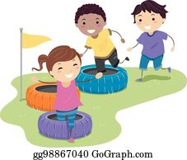
Gross Motor Skills:
- Build and complete obstacle courses
- Keep a balloon up in the air

- Ride a trike, bike or scooter
- Play hopscotch
- Play ball games involving kicking, catching, rolling, pushing
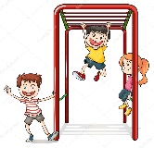
- Dance!
- Swimming and water play
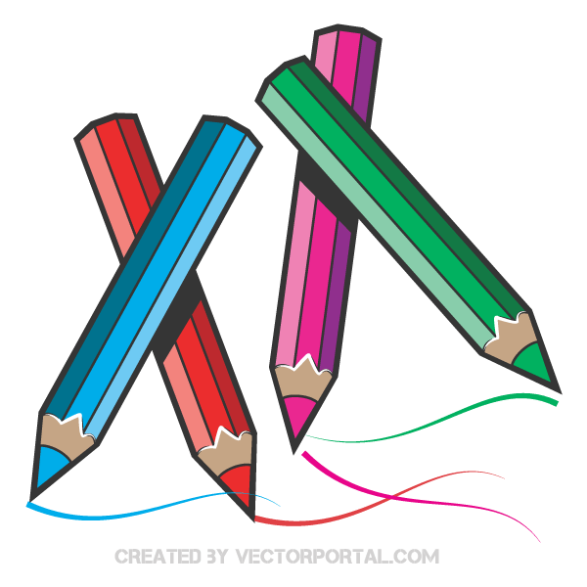
- Swinging, sliding and climbing at a playground
Fine Motor Skills:
- Mark making – children could use paintbrushes, crayons, chalks, water, sand, sticks in the mud etc to draw or write
- Colouring in, drawing around stencils, tracing
- Cooking (pouring, shaking, sprinkling, kneading, tearing, cutting with a butter knife)
- Lacing cards or stringing beads
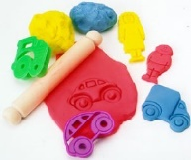
- Manipulative toys such as blocks, puzzles, or dolls with clothes to take on and off
- Play with play doh, use fingers to rip, roll and pull, scissors to cut, cutters to shape
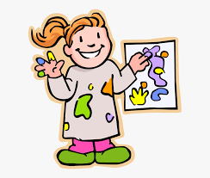
- Poke straws into hols (colander, grater, pots with holes in)
- Make a pasta necklace
- Finger-painting, painting with cotton buds
- Building 3D models using lego, wooden blocks, small cardboard boxes and tubes
Scissor Skills:
Using scissors correctly strengthens the same muscles that are needed to manipulate pens and pencils in a tripod grip. The correct grip is for the thumb and middle finger to fit into the handles, with the index finger outside to stabilise, and fingers four and five curled into the palm.
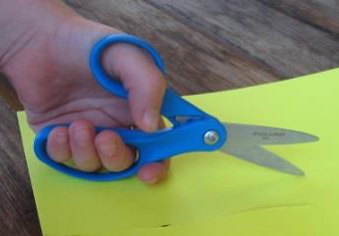
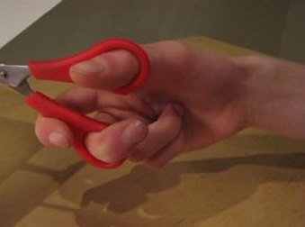
The thumb always stays on top and the scissors move straight ahead away from the body. We move the paper to cut in different directions. To start with some children will need you to manipulate the paper.

- Cut up junk mail and count the pieces or put together as a puzzle (or challenge another person to do so!)
- Draw a face and cut a fringe for hair
- Cut playdough or pastry
- Snip shredded paper into shorter and shorter strips. Order in size length: shortest, longer, longest, thinnest, widest
- Cut corners off cards or set a challenge such as, “Cut a card into 5 pieces.”
- Draw a thick black line to cut along: to start with, thicker paper is easy to manipulate, or used birthday cards
- Cut along a curved line and then circles and ovals
- Cut out various shapes with different angles: squares, rectangles, triangles, hexagons, stars

As with most of our learning a little practice often, with lots of praise for effort, has the best results and prevents frustration. Using a kitchen timer to set a real time limit helps many children – a lot can be achieved in 5 minutes. Stop often to rest hands and shake out tight muscles. Focus on having fun and taking time!

