BIRCHINGTON CE PRIMARY SCHOOL
May 2026
Dear parents/carers,
With term 6, and the excitement that comes with it, fast approaching, we wanted to contact you to let you know what you and your child can expect from the coming weeks.
The children are beginning to organise their production taking place on Monday 15th June at 1:30pm and Tuesday 16th June at 6:00pm. Tickets for this will be available to book on EventBrite from 5pm on Friday 22nd May using the links below. To allow everyone the opportunity to see their child, we are restricting tickets to 2 per child in the initial round. Please note, this is a total of two tickets, not two tickets per production. We will then release any remaining tickets on Monday 6th June where you can order additional tickets.
Monday afternoon performance booking link:
https://www.eventbrite.co.uk/e/year-6-production-monday-afternoon-tickets-1988514155368?aff=oddtdtcreator
Tuesday evening performance link:
https://www.eventbrite.co.uk/e/year-6-production-tuesday-16th-june-tickets-1989172066197?aff=oddtdtcreator
Your child will be bringing home their leavers hoody at the end of this term. These are not to be worn in school until the week beginning the 22nd June. We understand that your child will be excited to wear them, and we are allowing them to wear them on normal school days as well as activity days but are keen to keep the children settled, hence not permitting them until this time.
Also attached to this email is your child’s itinerary so that it is easy to keep track of what is happening on each day. The children will be continuing to work on their foundation subjects and we have lots of exciting lessons planned for when they are not taking part in leavers’ activities.
Below, you will find a Google form link. Please use this to inform us of your child’s food choices for the various activities. We need to liaise with outside agencies and the school kitchen to arrange food orders so completion of this, by June 5th, is appreciated.
https://docs.google.com/forms/d/e/1FAIpQLScqTKvFzVilpr8ecq2G7IAcGFGWf4i5JHAM2kyhxLcOJ3OTZg/viewform?usp=publish-editor
Finally, I would like to take this opportunity to thank you for all your support over this year. It has been a delight to teach your child and we are looking forward to giving them the best possible send off in July!
Warm wishes,
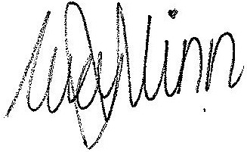

Lucy Winn, 6W Class teacher

